Documentation graph, python implementation

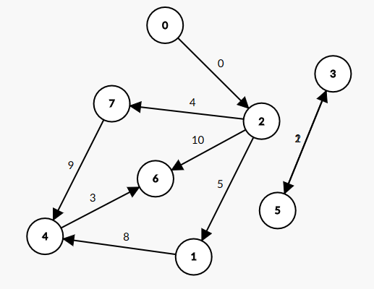

self._vertices = {0, 1, 2, 3, 4, 5, 6, 7}

self._neighbours = { 0 : {2}, 1 : {4}, 2 : {1, 6, 7}, 3 : {5}, 4 : {6}, 5 : {3}, 6 : {}, 7 : {4} }

self._transpose = { 0 : {}, 1 : {2}, 2: {0}, 3 : {5}, 4 : {1, 7}, 5 : {3}, 6 : {2, 4}, 7 : {2} }

self._cost = { (3, 5) : 2, (5, 3) : 1, (2, 1) : 5, (2, 6) : 10, (2, 7) : 4, (0, 2) : 0, (1, 4) : 8, (4, 6) : 3, (7, 4) : 9 }

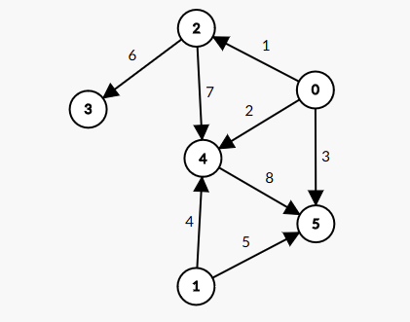

self._vertices = {0, 1, 2, 3, 4, 5}

self._neighbours = { 0 : {2, 4, 5}, 1 : {4, 5}, 2 : {3, 4}, 3 : {}, 4 : {5}, 5 : {} }

self._transpose = { 0 : {}, 1 : {}, 2: {0}, 3 : {2}, 4 : {0, 1, 2}, 5 : {0, 1, 4} }

self._cost = { (0, 2) : 1, (0, 4) : 2, (0, 5) : 3, (2, 3) : 6, (2, 4) : 7, (4, 5) : 8, (1, 4) : 4, (1, 5) : 5 }